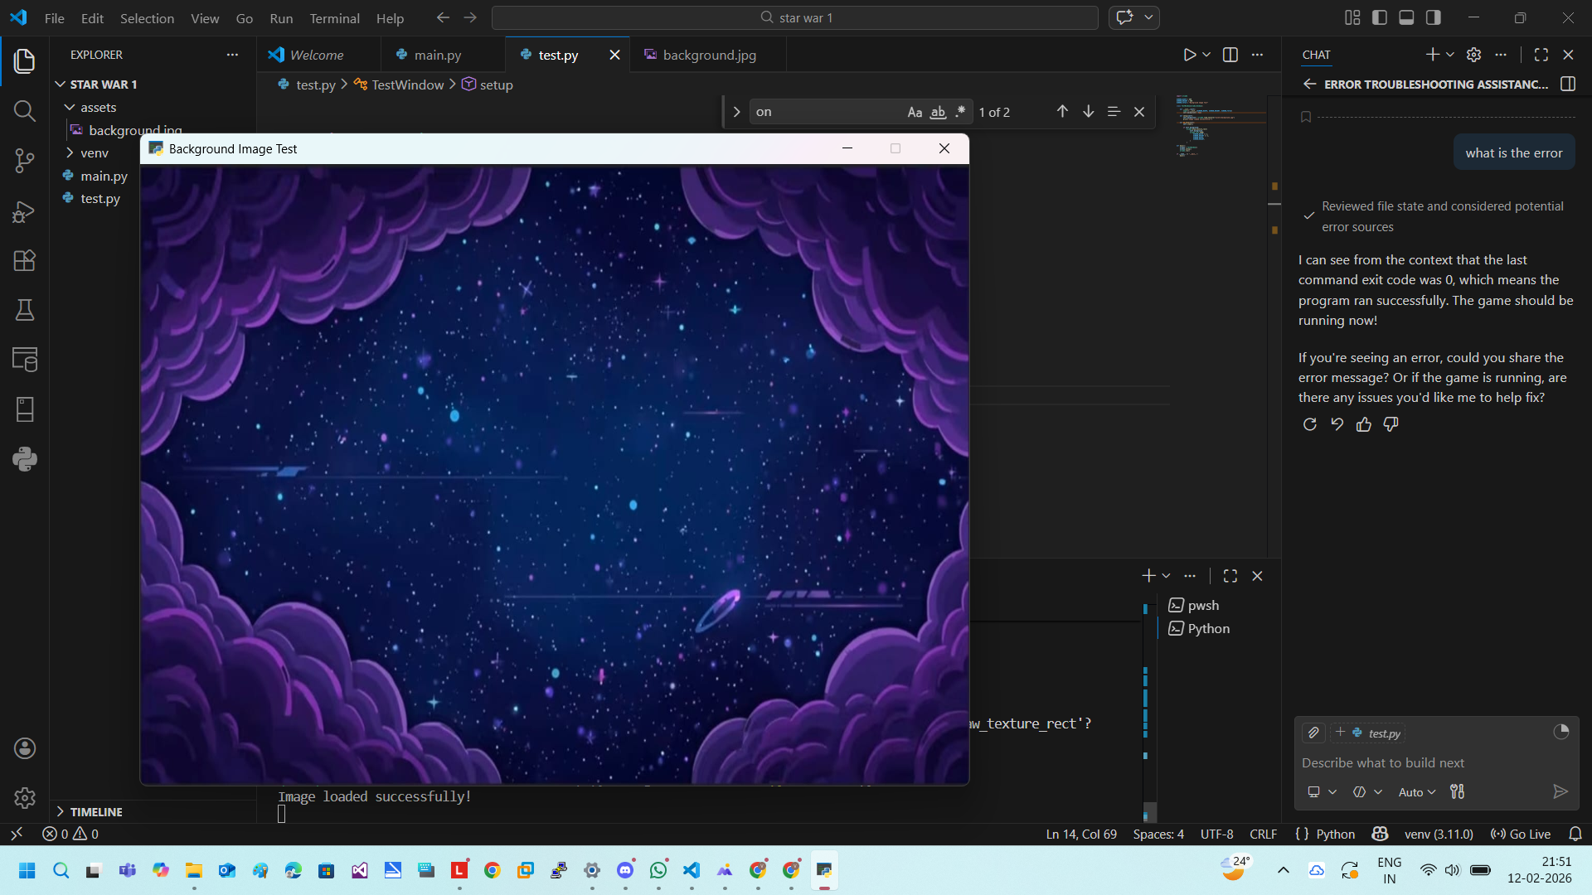

import arcade

SCREEN_WIDTH = 800
SCREEN_HEIGHT = 600
SCREEN_TITLE = "Background Image Test"

class TestWindow(arcade.Window):

def __init__(self):
super().__init__(SCREEN_WIDTH, SCREEN_HEIGHT, SCREEN_TITLE)
self.background = None

def setup(self):
self.background = arcade.load_texture("assets/background.jpg")
print("Image loaded successfully!")

def on_draw(self):
self.clear()

if self.background:
arcade.draw_texture_rect(
self.background,
arcade.rect.XYWH(
SCREEN_WIDTH // 2,
SCREEN_HEIGHT // 2,
SCREEN_WIDTH,
SCREEN_HEIGHT,
)
)

def main():
window = TestWindow()
window.setup()
arcade.run()

if __name__ == "__main__":
main()

